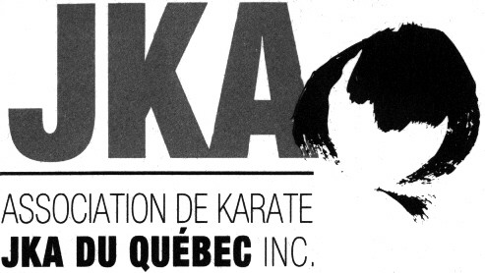 | Summer Camp  June 21 to 25, 2023
Registration Form
Dan and Qualifications Exams

Last Name : |  |  |  |  | First Name :
Rank : |  |  |  |  | Dojo :

Dan Examen

- SHODAN $ 280 CAD  - NIDAN $ 340 CAD  - SANDAN $ 380 CAD | - YONDAN $ 450 CAD  - GODAN $ 750 CAD

Qualifications Exams
(registration fee included)

- INSTRUCTOR D $ 140 CAD
- INSTRUCTOR C $ 140 CAD
- JUDGE D $ 140 CAD
- JUDGE C $ 140 CAD
- EXAMINER D $ 200 CAD
- EXAMINER C $ 300 CAD

*Payment by check for the Dan and Qualification Exams must be received before June 16 2023 at 108 Rue des Tilleuls, St-Basile-Le-Grand, Qc, J3N 1G2. Checks must be made to the order of Jean-Pierre Cusson. Payments in cash will be made on the first day of the Camp.

**Only JKA members who registered for at least a half-Camp having a JKA passport and a valid member card will be accepted to the Dan and Qualification Exams. You will have to present your JKA passport at the beginning of the Camp as well as the Examiner’s Record if applicable. Please indicate the name of your Instructor in the reference section.

Eligibility criteria for qualifications exams
Prerequisites for Instructor D: Nidan or above and 20 years old or older
Prerequisites for Instructor C : More than 3 months after receiving Sandan, Instructor D
Prerequisites for Judge D: Nidan or above and 20 years old or older, Instructor D.
Prerequisites for Examiner D: Sandan for at least 3 months, Instructor D, Judge D and 25 years old or older
Prerequisites for Examiner C : More than 3 months after receiving 4th Dan, more than 1 year after receiving Examiner D,
Instructor C, Judge C
***It is possible to take more than one Level D qualification exam on the same day.

For more information, please contact Jean-Pierre Cusson at (450) 441-1061 or by email karate.jka@videotron.ca.
-----------------------------------------------------------------------
Rules regarding the use of cameras, videos, cellulars, etc. during AKJKAQ activities.
It is strictly forbidden to photograph, film or take pictures with any device without permission from AKJKAQ.
For more information, please contact Jean-Pierre Cusson by email karate.jka@videotron.ca.

